**Question:**

Samsung is an appliances company, which makes communication devices and TV/LED. They are currently competing with other companies in the area of communication devices and TV/LED. The communication devices they produce, falls in the category of Cellular Phones and Tablets. However, they have an edge over other companies in that they are the only company that produces a Smart TV, which has all the features of a traditional TV as well as some functionalities of a modern communication device. As part of a deal, all the communication devices Samsung produce use Android as an operating system due to its rich features.

Consider the following classes and answer the questions below:

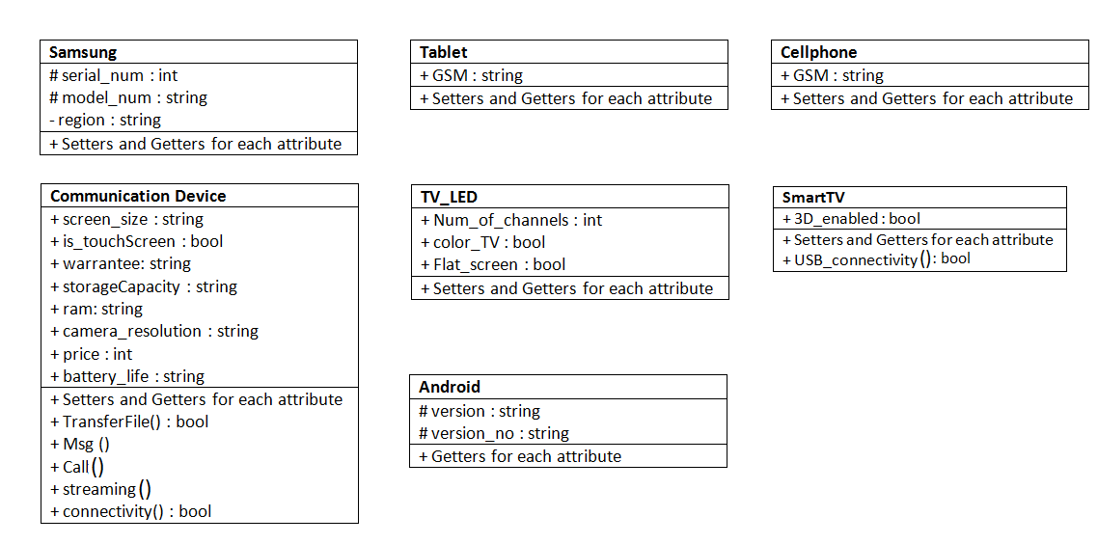

1. Illustrate how different objects will interact with each other using an Object interaction model.

|  |
| --- |
|  |

1. Identify the type(s) of inheritance present in the model and list different classes, which are involved in that particular type of inheritance.

|  |
| --- |
| * Single : (Communication Device - > tablet) , (Communication Device - > Cellphone) etc * Multilevel : (Android-> Communication Device ->CellPhone),   (Android-> Communication Device ->Tablet),  (Samsung-> Communication Device ->CellPhone),  (Samsung-> Communication Device ->Tablet)   * Multiple:   SmartTV inherits from Communication Device and TV_LED both  Hierarchical: Samsung class has two child classes( i.e. CD and TV_LED)  CommunicationDevice class has two child classes( i.e. Tablet and Cellphone )   * Hybrid Inheritance : Samsung -> CommunicationDevice & TV_LED ->SmartTV |

1. Provide implementation of all the classes present in the model (declaration syntax only).

|  |
| --- |
| class Android{};  class Samsung{};  class CommunicationDevice : virtual public Samsung, public Android{};  class TV_LED : virtual public Samsung{};  class SmartTV : virtual public TV_LED, virtual public CommunicationDevice {};  class Tablet : public CommunicationDevice {};  class Cellphone : public CommunicationDevice {}; |

1. The specialized classes (those classes that are not further derived) in each hierarchy must change the access modifier of all the parent data as private.

|  |
| --- |
| class SmartTV : private TV_LED, private CommunicationDevice {};  class Tablet : private CommunicationDevice {};  class Cellphone : private CommunicationDevice {}; |

1. The attribute (*serial_num*) in the root class is declared as **'*int*'** that is not sufficient to hold a 10 digit number, change its data type to double.

|  |
| --- |
| class CommunicationDevice : public Samsung{  double serial_num;  } |

1. To keep track of the total devices produced, Samsung must have a count of every type of product it makes. The count should be incremented, whenever a new device is created. Provide an appropriate mechanism for it.

|  |
| --- |
| class Samsung{  static int count;  public:  Samsung()  {  count++;  }  };  int Samsung::count=0; |

1. Overload the **msg()**function in *Cellphone* and *Tablet* classes to handle both SMS and MMS messages.

|  |
| --- |
| class Tablet{  void msg(string sms){  cout<<"Tablet's SMS message"<<endl;  }  void msg(string mms, int media){  cout<<"Tablet's MMS message"<<endl;  }};  class Cellphone{  void msg(string sms){  cout<<"Cellphone's SMS message"<<endl;  }  void msg(string mms, int media){  cout<<"Cellphone's MMS message"<<endl;  }}; |

1. Overload the **“>”** operator, so that it displays which of the two given communication devices has the latest android version.

|  |
| --- |
| class CommunicationDevice: public Samsung, public Android{  public:  bool operator >(const CommunicationDevice &obj) {  if(version > obj.version) {  return true;  }  return false;  }}  int main()  {  CellPhone p1,p2;  p1.setversion(12);  p2.setversion(13);  if(p1>p2)  cout<<"p1's version is higher"<<endl;  else  cout<<"p2's version is higher"<<endl;  } |

1. *SmartTV* is the product that accumulates functionalities from communication devices and TV/LED. Override all the necessary functions of communication devices and TV/LED in their derived classes.

|  |
| --- |
| class CommunicationDevice : virtual public Samsung, public Android {  public:  bool connectivity() {  // if connection is successful  return true;  // if connection unsuccessful  return false;  } };  class TV_LED : virtual public Samsung{  };  class SmartTV : virtual private TV_LED, virtual public CD{  public: bool USB_connectivity() {  if(success)  cout << "Connection established. ";  return true;  return false; }  bool connectivity()  {  cout << "Establishing USB connection... ";  return USB_connectivity();  } }; |

1. Assume there is global function **Investigate()** that wants to access the region where a specific .Samsung device operates. Provide the mechanism for it.

|  |
| --- |
| class Samsung{  private region;  // list of other attributes  public:  friend void investigate();  };  void investigate()  {  // can access private region variable of Samsung class  }  int main()  {  investigate(); } |